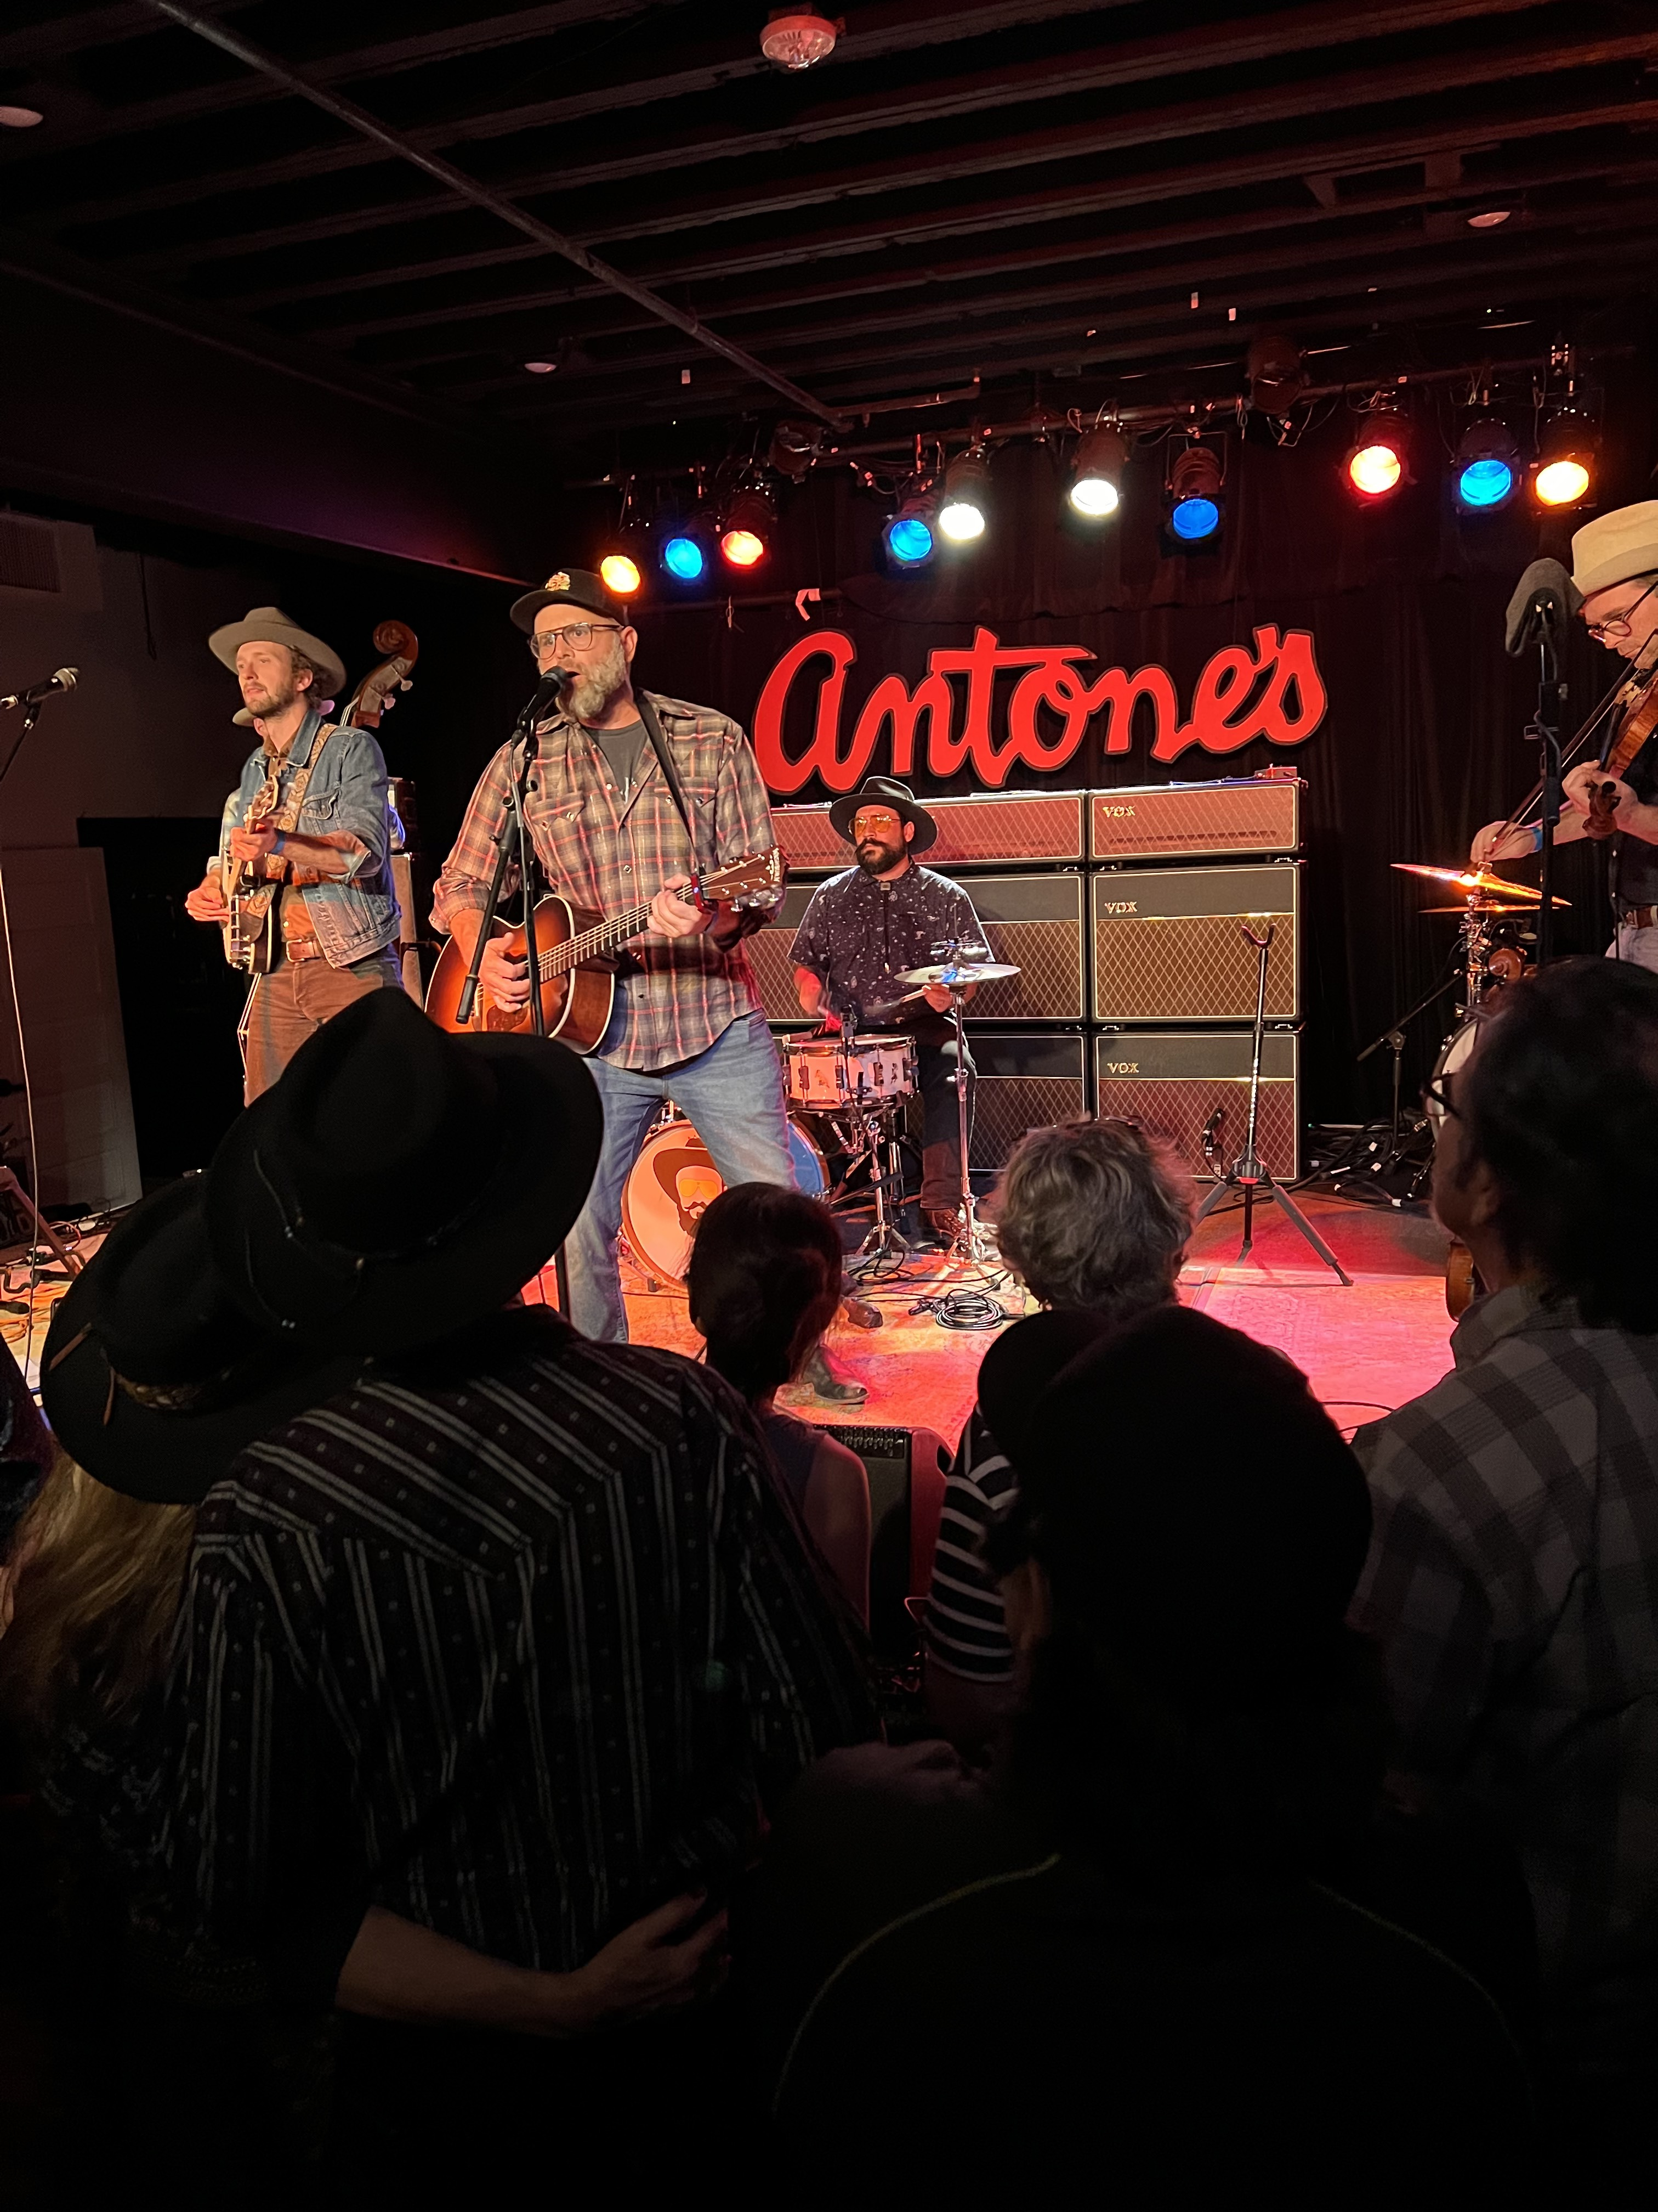

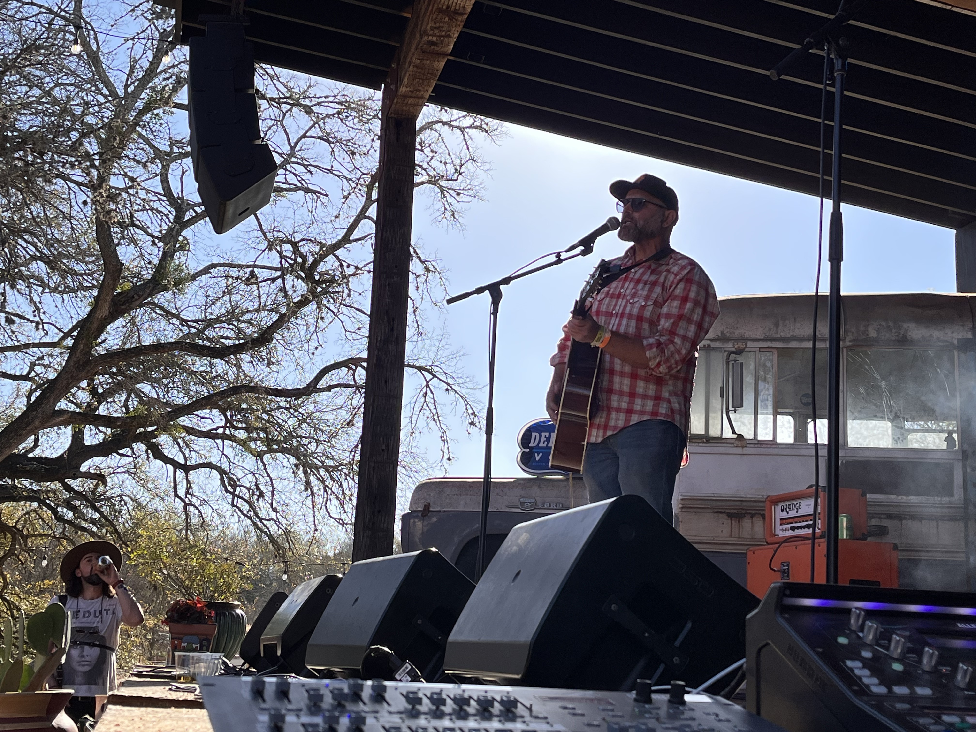
Stage 4 Head and Neck Cancer and losing his voice from severe radiation and chemo treatments set the stage for Derek Vanderhorst’s long recovery and the return to his passion of music. His journey to reclaim and reshape his life at the age of 50 set the stage for his raw cathartic and humorous storytelling style. Supported by his amazing friends Gabe Witcher of the Punch Brothers Jimmy Paxson of the Chicks, and world renowned bassist Mike Valerio, Derek released his first solo album Wildflower. With Wildflower, Derek hopes to empower and inspire others that it is never too late to find your voice: During recovery, he took stock of his life and relationships, writing more than 150 songs in the process. Eleven of those songs make up Wildflower– an album which captures his extraordinary personal journey. Derek has opened for BillyBob Thornton and played sold out shows at the famous Hotel Cafe in Los Angeles and
AIRPLAY DIRECT: http://airplaydirect.com/Wildflower

STREAMING: https://on.soundcloud.com/7Pfsc

WEBSITE: https://derekvmusic.com/epk

CONTACT: 323.397.1222 email
HOME BASE: Golden, Colorado

